For your safety as visitor

To ensure your safety as a visitor here at Boliden Aitik it is important that you are aware of some of our safety rules.

Logo.pdf

**Personal protective equipment for visitors in production environment**

Minimum requirements:

* Helmet with chin strap
* Eye protection
* Warning vest
* Protective shoes/boots

Depending on what parts of the industrial area you will visit you may also need, for example:

* Ear protection
* Gloves

**Ask your guide what equipment you will need during your visit**

**Other safety rules**

**In case of an emergency**, follow your guide´s instructions

* Always follow your guide´s instructions
* Visitors must not be under the age of 15
* A valid ID should be carried during the

whole visit

* Alcohol and narcotics are strictly

prohibited. Random alcohol and

narcotics tests may be carried out.

* Seat belts must always be used.
* Cameras may only be used with the permission of your guide.
* Publication of photos (including social media) requires the permission of Aitik’s area manager.

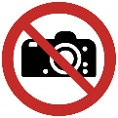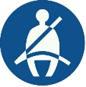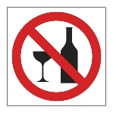

**Inform your guide if you:**

Have a pacemaker, epilepsy, allergies, fear of heights, is pregnant of for some other reason might have limitations during your visit, as this may affect what areas you can visit.

**I have read and understood the information on this paper and hereby commit to following these rules during my visit in Aitik.**

.................................. ....................................................

Date Signature

……………………………………………...

Name